MODULE:2(CSS AND CSS3)
- What are the benefits of using CSS? ANS:
- Improved site maintainability
- Improved Accessibility
- Improved Download speed
- Saves the time
- Supports multiple browsers

2)Are the disadvantages of CSS?
ANS:
- Limited Security
- Extra work for developers
- Confusion due to many css version

3)What is the difference between CSS2 and CSS3?
ANS:
- Responsive design is not supported in css but it supported in css3.
- Css does not support media querry but css3 is supported.
- New features of css3:
- psudo-elements= ::first-letter , ::first-line , ::after , ::before
- Border-style=border-radius , image source
- Background Style Properties = background-clip

4)Name a few CSS style components
ANS:
- Selector: element , id , class.
- Property : It’s like background color,font-size,position,text- align,color,border,etc.

5)What do you understand by CSS opacity?
ANS:
The opacity property sets the opacity level for an element. For example,
<!DOCTYPE html>
<html lang="en">

<head>
<meta charset="UTF-8">
<meta http-equiv="X-UA-Compatible" content="IE=edge">
<meta name="viewport" content="width=device-width, initial-scale=1.0">
<title>Document</title>
</head>
<style>
img {
opacity: 0.4
}
</style>
<body>
<img src="img/myphoto.JPG" alt="">
</body>
</html>

Output:
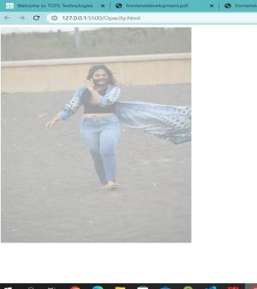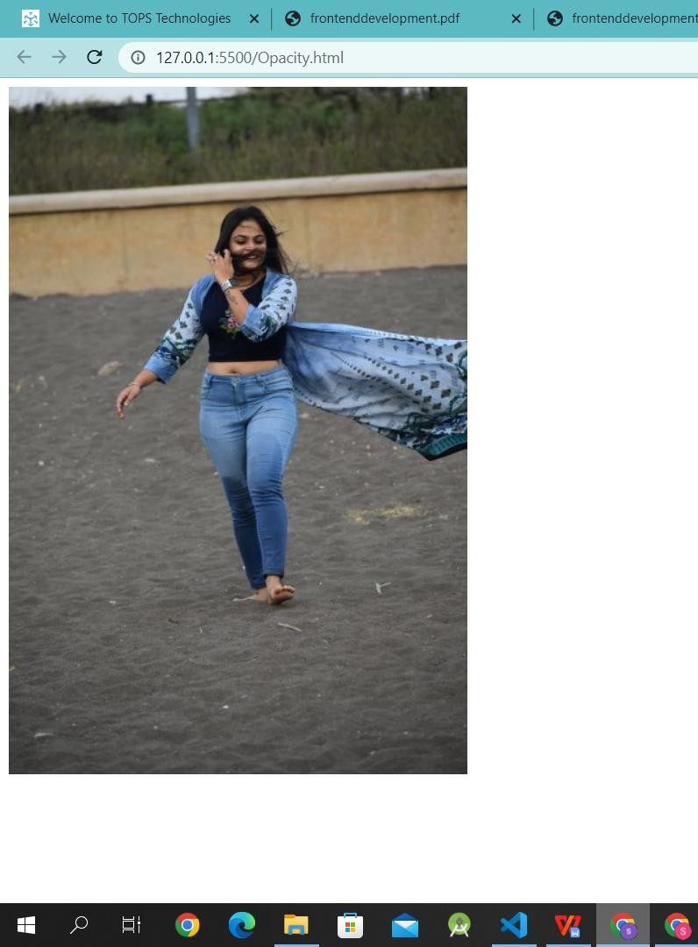
Opacity=0.4 opacity=1

ANS:
6)How can the background color of an element be changed?

We can use css property = background-color:red;
Example Code:
<!DOCTYPE html>
<html lang="en">
<head>
<meta charset="UTF-8">
<meta http-equiv="X-UA-Compatible" content="IE=edge">
<meta name="viewport" content="width=device-width, initial-scale=1.0">
<title>Document</title>
<style>
body {
background-color: coral;
}
</style>
</head>
<body>
<h1>Lorem</h1>
<p>Lorem ipsum, dolor sit amet consectetur adipisicing elit. Assumenda velit sint ab ullam? Quam quibusdam doloribus</p>
</body>
</html>
</body>
</html>

Output:
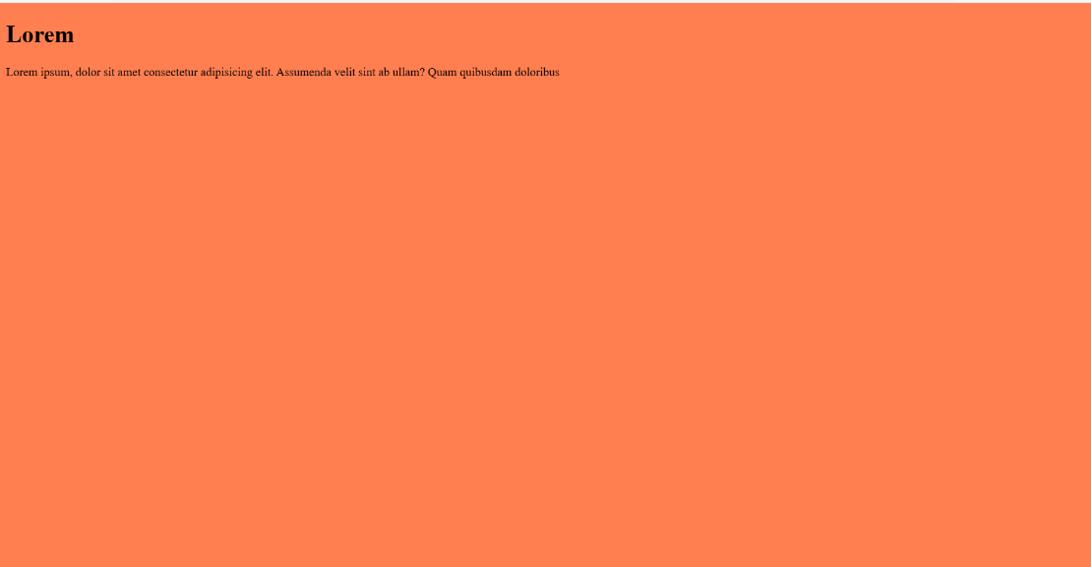

7)How can image repetition of the backup be controlled?
ANS:
Use repeat property
- background-repeat:repeat;
- background-repeat:repeat-x;
background-repeat:repeat-y;
- background-repeat:no repeat;
Example Code:
<!DOCTYPE html>
<html>
<head>
<style>
body {
margin-top: 40px;
background-image: url("discovery-454.jpg");
background-repeat: repeat-x;
background-size: 200px 200px;
}
h1 {
text-align: center;
}
</style>
</head>
<body>
<h1>Lorem</h1>
</body>
</html>
Output:
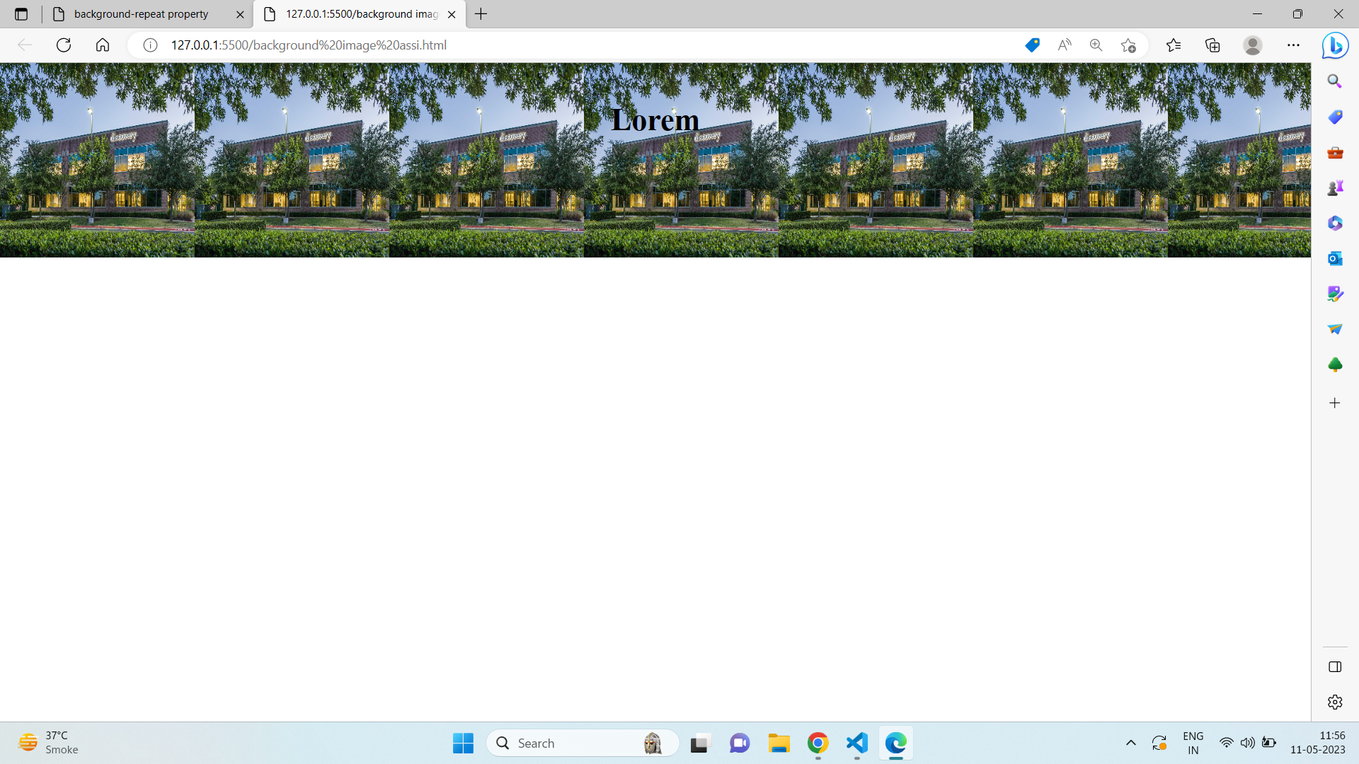

8)What is the use of the background-position property?
ANS:
The background-position property sets the starting position of a background image.
Property=background-position:center;
Example Code:
<!DOCTYPE html>
<html>
<head>
<style>
body {
background-image: url("discovery-454.jpg");
background-repeat: no-repeat;
background-attachment: fixed;
background-size: 500px 500px;
background-position: right top;
}
</style>
</head>
<body>
</body>
</html>
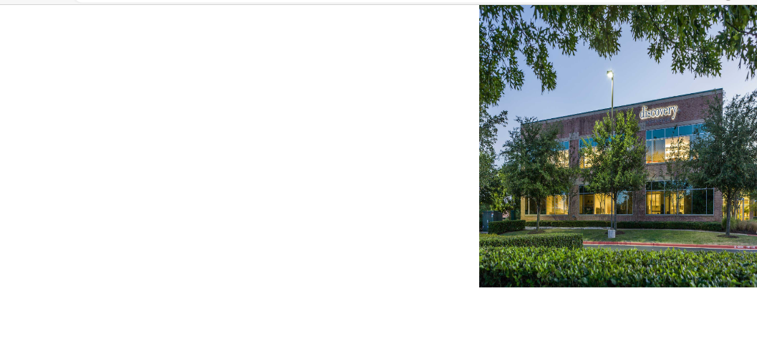

ANS:
9)Which property controls the image scroll in the background?

background-attachment: scroll;
Example code:
<!DOCTYPE html>
<html>
<head>
<style>
#one {
background-image:url("xCustomer-lifecycles_03-800x480.png.pagespeed.ic.CYgJqwksgU.png");
background-position: center;
background-repeat: no-repeat;
background-attachment: scroll;
}
</style>
</head>
<body>
<div id="one">
<p>
Lorem ipsum dolor sit amet consectetur adipisicing elit. Nobis,<br> <br> <br> suscipit placeat debitis nemo laboriosam <br> <br> <br>hic perferendis facere esse sed voluptatibus facilis, ad officiis?<br> <br> <br> Reiciendis optio blanditiis, at doloremque maxime necessitatibus. Et quidem fuga aperiam recusandae. Sapiente iure qui <br> <br> <br>inventore quas incidunt quod optio. Rem nobis ipsa at quos quis distinctio harum, <br> <br> <br>culpa et! Mollitia, rerum delectus impedit maiores laudantium iusto.<br> <br> <br>A architecto cupiditate libero perferendis illo <br> <br> <br>tempore dolorum doloremque fugit quasi magnam, sunt,<br> <br> <br> harum modi similique nesciunt hic voluptatibus odio quis voluptas delectus, vitae tenetur omnis corrupti corporis voluptates! Saepe?Porro animi voluptate praesentium quo. Laboriosam <Br> <br> quis harum magni non possimus <br> <br> <br> est eum qui, repellat excepturi, ipsa eos <br> <br> <br>exercitationem dolorum blanditiis quia deserunt aliquid sint illo quaerat modi distinctio! Dolorem?Animi repellat dolores earum quia obcaecati velit<br> <br> <br> odit amet beatae. Provident modi ad quibusdam quia vel <br> <br> <br>officiis tenetur laudantium! Voluptatibus odio quae reprehenderit illo,<br> <br> <br> unde labore consectetur minus blanditiis asperiores.
</p>
</div>
</body>
</html>

Output:
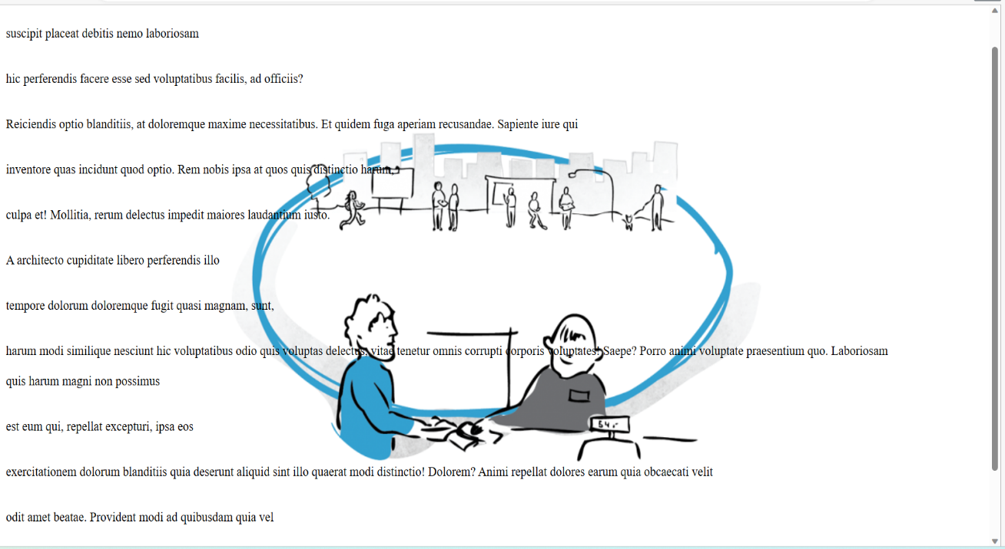
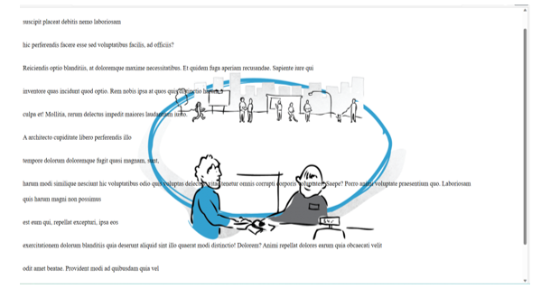

ANS:
10))Why should background and color be used as separate properties?

The background-color property sets the background color of an element.
The color property specifies the color of text.
Example Code:
<!DOCTYPE html>
<html lang="en">
<head>
<meta charset="UTF-8">
<meta http-equiv="X-UA-Compatible" content="IE=edge">
<meta name="viewport" content="width=device-width, initial-scale=1.0">
<title>Document</title>
<style>
div {
height: 500px;
width: 500px;
background: fixed;
background-color: teal;
color: white;
}
</style>
</head>
<body>
<div>
Lorem ipsum dolor sit amet consectetur adipisicing elit. Asperiores iure fugit sapiente
sequi architecto, fugiat, impedit natus facere quo consectetur cumque magni nemo
modi omnis beatae illum sit quisquam recusandae.
</div>
</body>
</html>
Output:
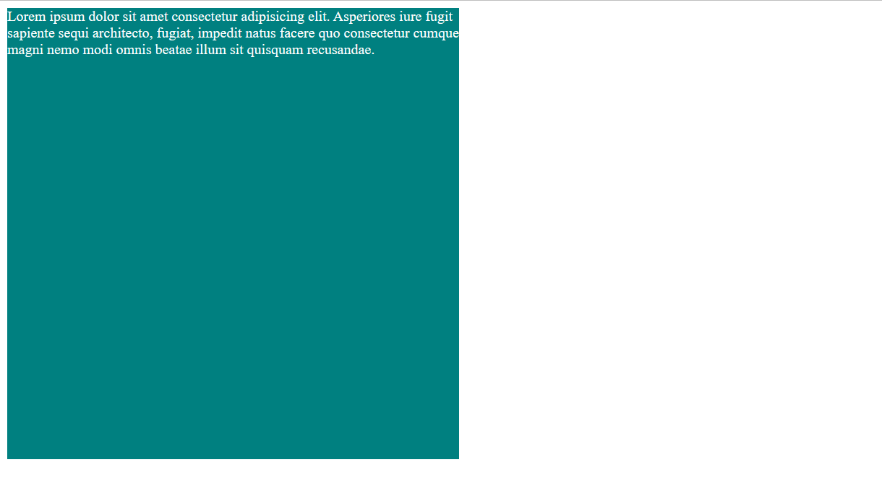
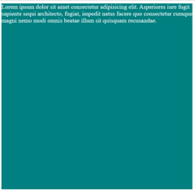

11)How to center block elements using CSS1?
ANS: margin:auto;
Text-align:center;
Example Code:
<!DOCTYPE html>
<html lang="en">
<head>
<meta charset="UTF-8">
<meta http-equiv="X-UA-Compatible" content="IE=edge">
<meta name="viewport" content="width=device-width, initial-scale=1.0">
<title>Document</title>
<style>
div {
border: 2px solid black;
height: 250px;
margin-left: auto;
margin-right: auto;
width: 250px;
}
</style>
</head>
<body>
<div></div>
</body>
</html>
Output:
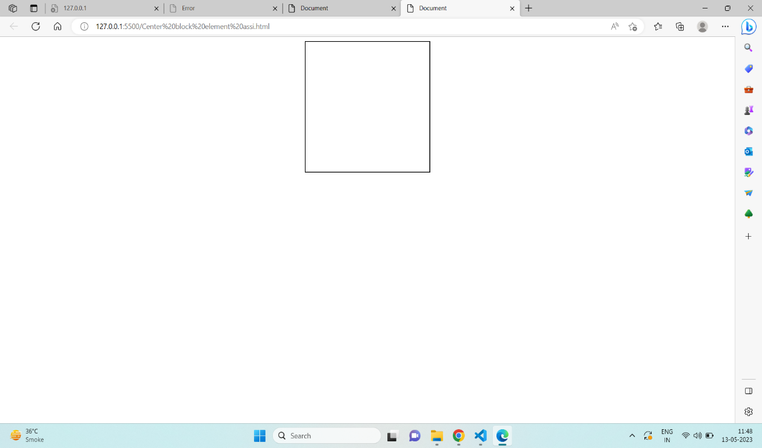


12)How to maintain the CSS specifications?
ANS: Specification specify hoe stylesheets can be included in your web document and how to target specific media.
The Specification also include:
- The syntax and data types of the language
- Detailed explanation on CSS Selectors
- How you can assign values to properties
- The Cascade (the "C" in CSS)
- How inheritance works
- The Box Model

13)What are the ways to integrate CSS as a web page?
ANS:
There are three ways:
- INLINE :by using the style attribute inside HTML elements.
- INTERNAL: by using the <style> element in the <head> section.
- EXTERNAL: by using a <link> element to link to external css file.
Example Code:External CSS
<!DOCTYPE html>
<html lang="en">
<head>
<meta charset="UTF-8">
<meta http-equiv="X-UA-Compatible" content="IE=edge">
<meta name="viewport" content="width=device-width, initial-scale=1.0">
<title>Document</title>
<link rel="stylesheet" href="style.css">
</head>
<body>
<h1>Lorem</h1>
<p>Lorem ipsum dolor sit amet consectetur adipisicing elit.</p>
</body>
</html>
External CSS Code:
body {
background-color: lightblue;
}
h1 {
color: navy;
margin-left: 50px;
}
Output:
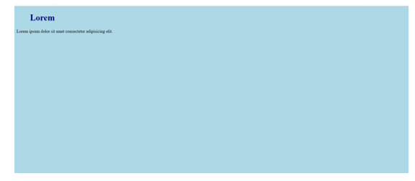vvvvvv
Internal CSS
Example Code:
<!DOCTYPE html>
<html lang="en">
<head>
<meta charset="UTF-8">
<meta http-equiv="X-UA-Compatible" content="IE=edge">
<meta name="viewport" content="width=device-width, initial-scale=1.0">
<title>Document</title>
<style>
body {
background-color: blueviolet;
}
h1 {
color: white;
margin-left: 50px;
}
</style>
</head>
<body>
<h1>Lorem</h1>
<p>Lorem ipsum dolor sit amet consectetur adipisicing elit.</p>
</body>
</html>
Output:
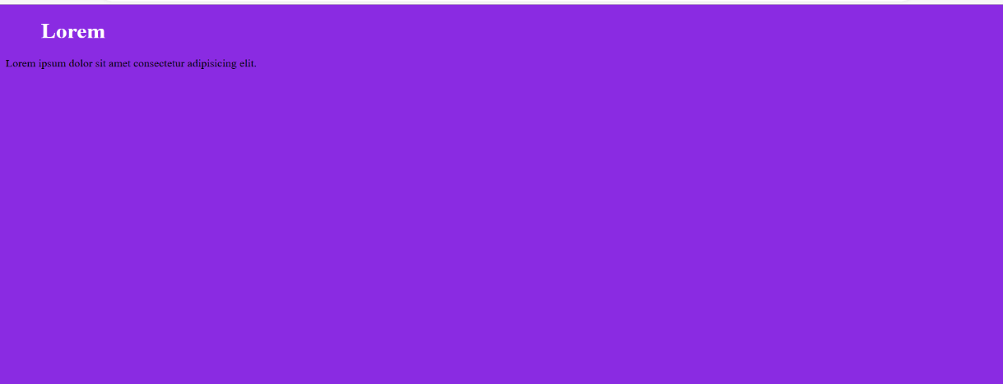
Inline CSS
Example Code:
<!DOCTYPE html>
<html lang="en">
<head>
<meta charset="UTF-8">
<meta http-equiv="X-UA-Compatible" content="IE=edge">
<meta name="viewport" content="width=device-width, initial-scale=1.0">
<title>Document</title>
<body>
<h1 style="color:blue;text-align:center;">lorem</h1>
<p style="color:red;">Lorem ipsum dolor sit amet consectetur adipisicing elit.</p>
</body>
</html>
Output:
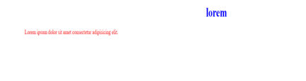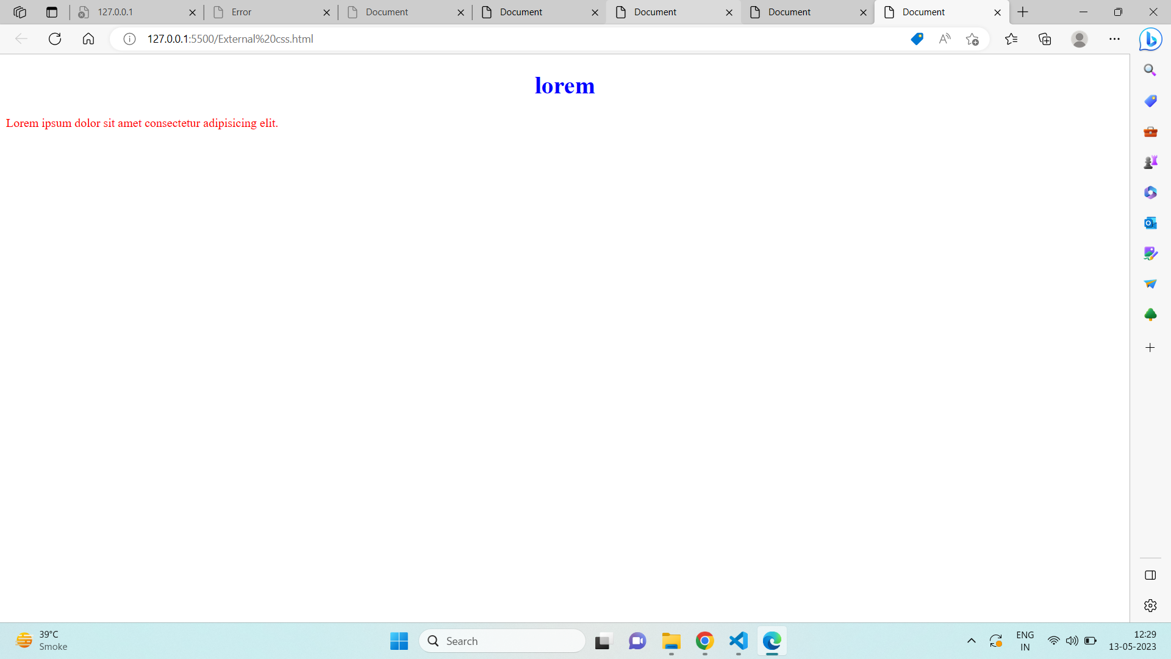

14)What is embedded style sheets?
ANS:
This is done by embedding the <style></style> tags containing the CSS properties in the head of your document.
Example Code:
<!DOCTYPE html>
<html>
<head>
<!-- Embedded stylesheet -->
<style>
h2 {
font-size: xx-large;
color: blue;
text-align: center;
}
p {
text-align: center;
background-color: green;
}
</style>
</head>
<body>
<h2>Lorem</h2>
<p>Lorem ipsum dolor sit amet consectetur adipisicing elit</p>
<p>Lorem ipsum dolor sit amet consectetur adipisicing elit</p>
<p>Lorem ipsum dolor sit amet consectetur adipisicing elit</p>
</body>
</html>
Output:
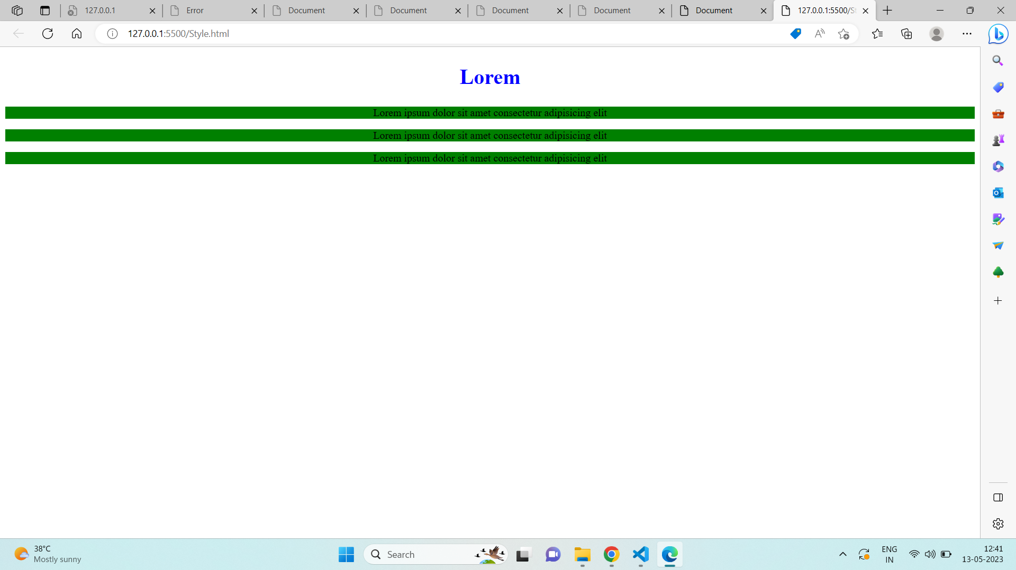


15)What are the external style sheets?
ANS: External styles are defined within the <link> element, inside the <head> section of an HTML page:
Example Code:
<!DOCTYPE html>
<html lang="en">
<head>
<meta charset="UTF-8">
<meta http-equiv="X-UA-Compatible" content="IE=edge">
<meta name="viewport" content="width=device-width, initial-scale=1.0">
<title>Document</title>
<link rel="stylesheet" href="style.css">
</head>
<body>
<h1>Lorem</h1>
<p>Lorem ipsum dolor sit amet consectetur adipisicing elit.</p>
</body>
</html>
External CSS Code:
body {
background-color: lightblue;
}
h1 {
color: navy;
margin-left: 50px;
}
Output:

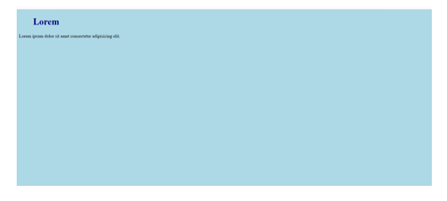

16)wha are advantages and disadvantages of using external style sheets?
Advantages:
You can use .css file for multiple pages.
Disadvantages of external CSS:
1) In order to import style information for each document, an extra download is needed.
2) Until the external style sheet is loaded, it may not be possible to render the document.
3) For small number of style definitions, it is not viable.

17)What is the meaning of the CSS selector?
ANS: Below are the types of CSS selector
- CSS element selector: The element selector selects HTML elements based on the element name.
- CSS ID selector: The id of an element is unique within a page, so the id selector is used to select one unique element write a hash (#) character, followed by the id of the element
- CSS Class selector: The class selector selects HTML elements with a specific class attribute.To select elements with a specific class, write a period (.) character, followed by the class name.
- CSS universal selector: The universal selector (*) selects all HTML elements on the page.
- CSS grouping selector: The grouping selector selects all the HTML elements with the same style definitions.

18)What are the media types allowed by CSS?
ANS:
We can add the breakpoint to see the screen width along with the width and height of the viewport for the different devices.
A breakpoint is a point or key that determines when to change the layout by reshaping & adding new rules inside the media queries. There are some common breakpoints, not a standard resolution, that can be used for the different widths & heights of devices:

media types:

- For Mobile devices: 320px-480px
- For Tablets or iPad: 480px - 768px
- For Laptop or small-size screen: 768px -1024px
- For Desktop or large-size screen: 1024px -1200px
- For Extra-large size device: 1200px and more

19)What is the rule set?
ANS:
A CSS rule set contains one or more selectors and one or more declarations.

Example:
Selector->h1{
property->color:red <-value
Declaration box
}
-The selector indicates which type of content is to be styled by the CSS rule.In the CSS example, the selector is the <h1> HTML element, which is a tag selector
- The declaration block is the part of the CSS rule that declares a style rule for the selector. In the CSS example, the declaration block is color:blue;.
-The property refers to the property of the HTML content that the CSS rule will modify, such as font-size or color. In the CSS example, the property is color.
-The value refers to the specific value assigned to the property, such as 16px or red. In the example CSS rule, the value is red.
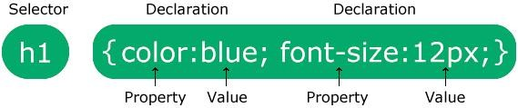
20)Create image gallery using display grid with responsive

Ans: <!DOCTYPE html>
<html lang="en">
<head>
<meta charset="UTF-8">
<meta http-equiv="X-UA-Compatible" content="IE=edge">
<meta name="viewport" content="width=device-width, initial-scale=1.0">
<title>Document</title>
<style>
div {
display: grid;
grid-template-columns: repeat(12);
}
.one {
border: 10px black solid;
padding: 20px;
}
#line1 {
grid-column: 1/7;
height: 200px;
background-image: url(image\ chiken.html.png);
background-repeat: no-repeat;
background-size: cover;
}
#line2 {
grid-column: 7/12;
background-image: url(image\ chiken.html.png);
background-repeat: no-repeat;
background-size: cover;
}
#line3 {
grid-column: 1/4;
height: 200px;
background-image: url(image\ chiken.html.png);
background-repeat: no-repeat;
background-size: cover;
}
#line4 {
grid-column: 4/8;
background-image: url(image\ chiken.html.png);
background-repeat: no-repeat;
background-size: cover;
}
#line5 {
grid-column: 8/12;
background-image: url(image\ chiken.html.png);
background-repeat: no-repeat;
background-size: cover;
}
#line6 {
grid-column: 1/6;
height: 200px;
background-image: url(image\ chiken.html.png);
background-repeat: no-repeat;
background-size: cover;
}
#line7 {
grid-column: 6/12;
background-image: url(image\ chiken.html.png);
background-repeat: no-repeat;
background-size: cover;
}
#line8 {
grid-column: 1/4;
height: 100px;
background-image: url(image\ chiken.html.png);
background-repeat: no-repeat;
background-size: cover;
}
#line9 {
grid-column: 4/8;
background-image: url(image\ chiken.html.png);
background-repeat: no-repeat;
background-size: cover;
}
#line10 {
grid-column: 8/12;
background-image: url(image\ chiken.html.png);
background-repeat: no-repeat;
background-size: cover;
}
</style>
</head>
<body>
<div>
<div class="one" id="line1"></div>
<div class="one" id="line2"></div>
<div class="one" id="line3"></div>
<div class="one" id="line4"></div>
<div class="one" id="line5"></div>
<div class="one" id="line6"></div>.
<div class="one" id="line7"></div>
<div class="one" id="line8"></div>
<div class="one" id="line9"></div>
<div class="one" id="line10"></div>
</div>
</body>
</html>

Output: 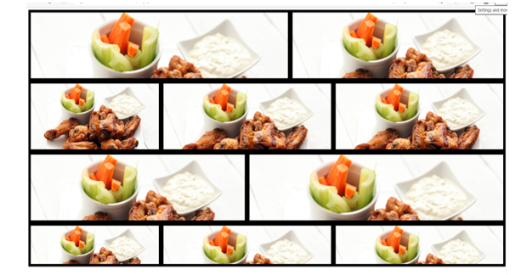

Que.21) Multiple background one side bg-color other side contain image as bg?
Ans: <!DOCTYPE html>
<html lang="en">
<head>
<meta charset="UTF-8">
<meta http-equiv="X-UA-Compatible" content="IE=edge">
<meta name="viewport" content="width=device-width, initial-scale=1.0">
<title>Document</title>
<style>
* {
margin: 0;
padding: 0;
box-sizing: border-box;
}
.container {
display: flex;
width: 1041px;
height: 768px;
background-color: #202020;
}
img {
position: relative;
left: 50%;
}
h3 {
position: relative;
top: 70px;
left: 700px;
font-size: 36px;
letter-spacing: 4px;
color: #f4f5f9;
font-weight: 700;
font-family: "Source Sans Pro";
}
h5 {
position: relative;
top: 130px;
left: 60%;
width: 587px;
height: 74px;
font-size: 18px;
line-height: 29px;
color: #e74c3c;
font-weight: 600;
font-family: "Open Sans";
text-align: right;
}
p {
position: relative;
top: 100px;
left: 400px;
color: white;
}
</style>
</body>
<div class="container">
<div id="one">
<h3>OUR SERVICES</h3>
<h5>Web Design</h5>
<p>Lorem ipsum dolor, sit amet consectetur adipisicing elit. Officia nesciunt quos, error commodi eius, ea
voluptas facilis velit laboriosam dignissimos sit veniam distinctio debitis nulla recusandae dicta
molestias. Expedita, earum!</p>
<h5>Print Design</h5>
<p>Lorem ipsum dolor sit, amet consectetur adipisicing elit. Quibusdam minus explicabo dolorum odio sapiente
libero incidunt unde temporibus aspernatur earum praesentium, assumenda maxime magni odit nemo facilis.
Qui, dolorum sed?</p>
<h5>Photography</h5>
<p>Lorem ipsum dolor sit amet consectetur, adipisicing elit. Sit consequuntur saepe, nam aliquam quidem
aspernatur modi autem facere dolor tempora, ipsa fugit in ipsum libero delectus molestias labore
expedita incidunt.</p>
</div>
<div id="two">
<img src="Put Your Image.svg" alt="">
</div>
</div>
</html>
Output:

Output: 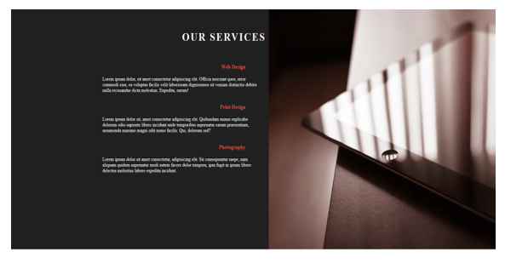vvvvvvv

Que. 22)Create below example using css waves generator?
Ans:
<!DOCTYPE html>
<html lang="en">
<head>
<meta charset="UTF-8">
<meta http-equiv="X-UA-Compatible" content="IE=edge">
<meta name="viewport" content="width=device-width, initial-scale=1.0">
<title>Document</title>
<style>
* {
margin: 0;
padding: 0;
box-sizing: border-box;
}
body {
background-image: url(assign\ image.jpg.svg);
background-size: cover;
background-repeat: no-repeat;
}
h1 {
position: relative;
top: 140px;
left: 40%;
font-size: 36px;
letter-spacing: 4px;
color: #ffffff;
font-weight: 700;
font-family: "Source Sans Pro";
}
p {
position: relative;
top: 150px;
left: 110px;
width: 1173px;
height: 36px;
font-size: 17px;
line-height: 29px;
color: #f4f5f9;
font-weight: 400;
font-family: "Open Sans";
text-align: center;
}
svg {
position: relative;
top: 170px;
opacity: 0.2;
}
h3 {
position: relative;
top: 50px;
left: 25%;
font-size: 24px;
letter-spacing: 2px;
text-transform: uppercase;
color: #e74c3c;
font-weight: 600;
font-family: "Open Sans";
}
.one {
position: relative;
top: 60px;
left: -100px;
font-size: 14px;
letter-spacing: 1px;
line-height: 24px;
color: #ffffff;
font-weight: 400;
font-family: "Source Sans Pro";
}
</style>
</head>
<body>
<h1>OUR TEAM</h1>
<p>Meet the craziest team. Share your thoughts with them.</p>
<svg xmlns="http://www.w3.org/2000/svg" viewBox="0 0 1440 320">
<path fill=" #e74c3c" fill-opacity="1"
d="M0,288L48,282.7C96,277,192,267,288,224C384,181,480,107,576,106.7C672,107,768,181,864,192C960,203,1056,149,1152,122.7C1248,96,1344,96,1392,96L1440,96L1440,320L1392,320C1344,320,1248,320,1152,320C1056,320,960,320,864,320C768,320,672,320,576,320C480,320,384,320,288,320C192,320,96,320,48,320L0,320Z">
</path>
</svg>
<h3>WEB DESIGNER</h3>
<p class="one">UI/UX Designer</p>
</body>
</html>

Output:
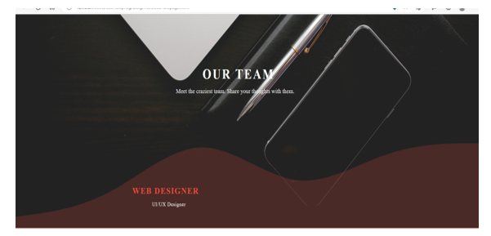vvv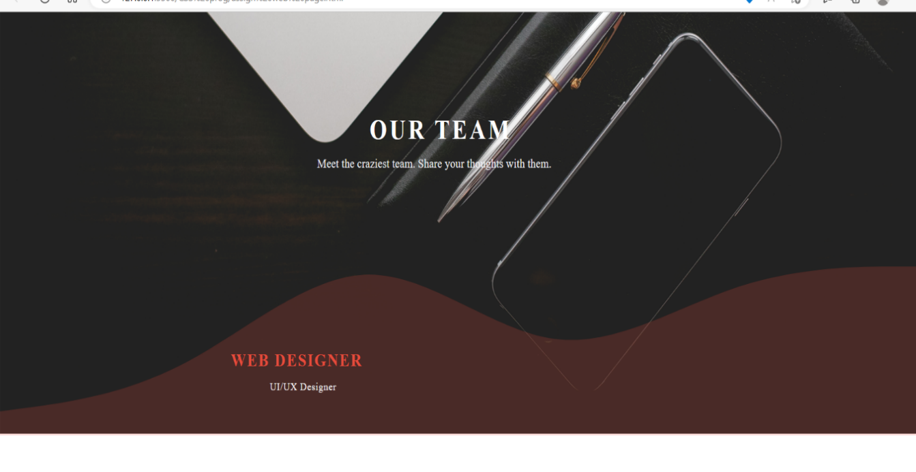

Que. 23) Create Layouts
Ans:Code
<!DOCTYPE html>
<html lang="en">
<head>
<meta charset="UTF-8">
<meta http-equiv="X-UA-Compatible" content="IE=edge">
<meta name="viewport" content="width=device-width, initial-scale=1.0">
<title>Document</title>
<style>
* {
margin: 0;
padding: 0;
box-sizing: border-box;
}
/* Card style */
.card {
display: inline-block;
height: 300px;
position: relative;
top: 20px;
left: 20px;
width: 20%;
margin-inline: 10px;
border: 2px solid gray;
}
.one
{
position: relative;
height: 130px;
padding: 40px;
background-color: rgba(12, 11, 11, 0.859);
color: white;
text-align: center;
}
p {
position: relative;
top: 20px;
padding: 15px;
text-align: justify;
}
button {
position: relative;
top: 30px;
left: 15px;
padding: 2px;
margin: 2px;
margin-inline: -2px;`
}
/* 4th to 6th card style */
.two {
position: relative;
top: -8px;
left: 75%;
}
.main-1 {
position: relative;
top: 20px;
}
</style>
</head>
<body>
<!-- 1st to 3rd card -->
<div class="main">
<!-- Card 1 -->
<div class="card">
<div class="one">
<h1>Thumbnail</h1>
</div>
<div>
<p>Lorem ipsum dolor sit amet consectetur, adipisicing elit. Vel nulla autem commodi eos assumenda </p>
<button>View</button>
<button>Edit</button>
<p class="two">lorem</p>
</div>
</div>
<!-- Card 2 -->
<div class="card">
<div class="one">
<h1>Thumbnail</h1>
</div>
<div>
<p>Lorem ipsum dolor sit amet consectetur, adipisicing elit. Vel nulla autem commodi eos assumenda </p>
<button>View</button>
<button>Edit</button>
<p class="two">lorem</p>
</div>
</div>
<!-- Card 3 -->
<div class="card">
<div class="one">
<h1>Thumbnail</h1>
</div>
<div>
<p>Lorem ipsum dolor sit amet consectetur, adipisicing elit. Vel nulla autem commodi eos assumenda </p>
<button>View</button>
<button>Edit</button>
<p class="two">lorem</p>
</div>
</div>
</div>
<!-- 4th to 6th card -->
<div class="main-1">
<!-- Card 4 -->
<div class="card">
<div class="one">
<h1>Thumbnail</h1>
</div>
<div>
<p>Lorem ipsum dolor sit amet consectetur, adipisicing elit. Vel nulla autem commodi eos assumenda </p>
<button>View</button>
<button>Edit</button>
<p class="two">lorem</p>
</div>
</div>
<!-- Card 5 -->
<div class="card">
<div class="one">
<h1>Thumbnail</h1>
</div>
<div>
<p>Lorem ipsum dolor sit amet consectetur, adipisicing elit. Vel nulla autem commodi eos assumenda </p>
<button>View</button>
<button>Edit</button>
<p class="two">lorem</p>
</div>
</div>
<!-- Card 6 -->
<div class="card">
<div class="one">
<h1>Thumbnail</h1>
</div>
<div>
<p>Lorem ipsum dolor sit amet consectetur, adipisicing elit. Vel nulla autem commodi eos assumenda </p>
<button>View</button>
<button>Edit</button>
<p class="two">lorem</p>
</div>
</div>
</div>
</body>
</html>

Output:
